

POWERBI

DATA GOVERNANCE DASHBOARD

(User Guide)



**Introduction**

This guide helps users understand how to use the Power BI Workspace Usage Dashboard built using Streamlit. The app connects to the Power BI REST API and helps users visualize report, dataset, and user activity across multiple workspaces.

**Software Requirements**:

Python

Streamlit (for the UI framework)

Power BI REST API Access (for fetching reports, datasets, and users)

Required Python libraries:

* streamlit
* pandas
* requests
* plotly
* seaborn

Tools: Visual Studio Code

**3. Step-by-Step User Guide:**

1.Install Required Packages:

2.Navigate to the app directory.

3.To Launch the App:

Streamlit run Home.py



**Authentication**

Copy your access token from microsoft.

Enter or confirm your email address.

Click the Authenticate button.

On success, you’ll be redirected to the Workspace Selection

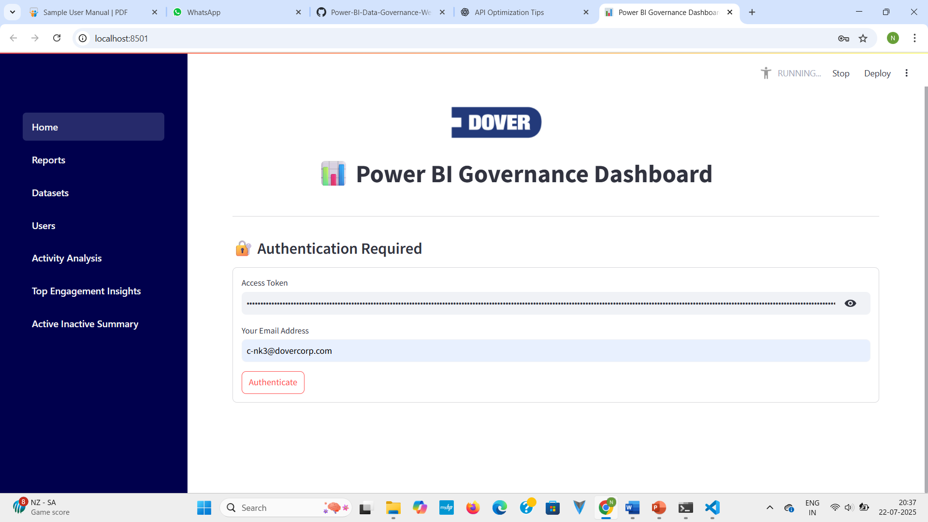

After successful authentication, you will be directed to the **Workspace Selection** page, where you can choose the Power BI workspace you wish to analyze.

After selection of Workspaces,

Use the **sidebar** to start exploring filtered insights based on your selected workspaces.

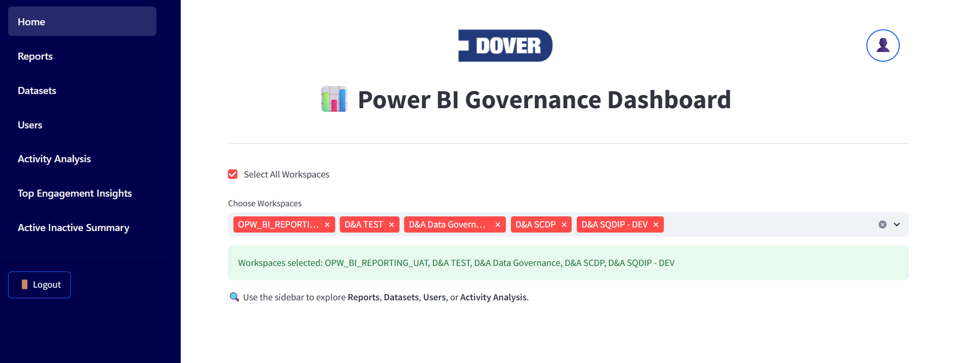

**Dashboard Navigation**

Use the sidebar to explore :

Reports, Datasets, Users , Activity Analysis ,Top Engagement Insights ,Active and Inactive assest

 **REPORTS**

This dashboard provides a comprehensive view of Power BI reports across the selected workspaces

**Click the button to analyze** the reports across your selected workspaces. The dashboard will display the following key metrics:

* **Total Reports**:  
  Shows the total number of Power BI reports available in the selected workspaces.
* **Up to Date**:  
  Displays the number of reports that are current and actively maintained.
* **Needs Attention**:  
  Highlights reports that may require updates, reviews, or verification.
* **Expired**:  
  Indicates reports that are outdated, unused, or no longer relevant.

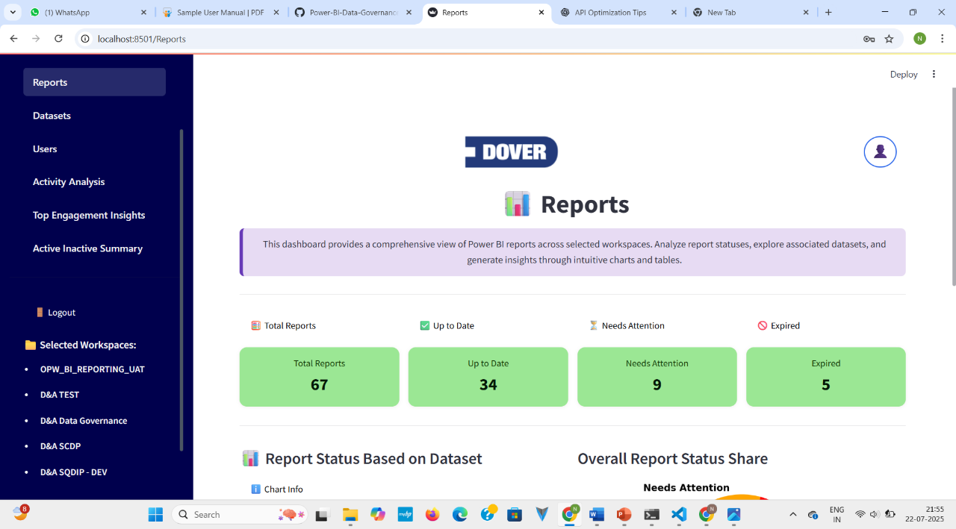

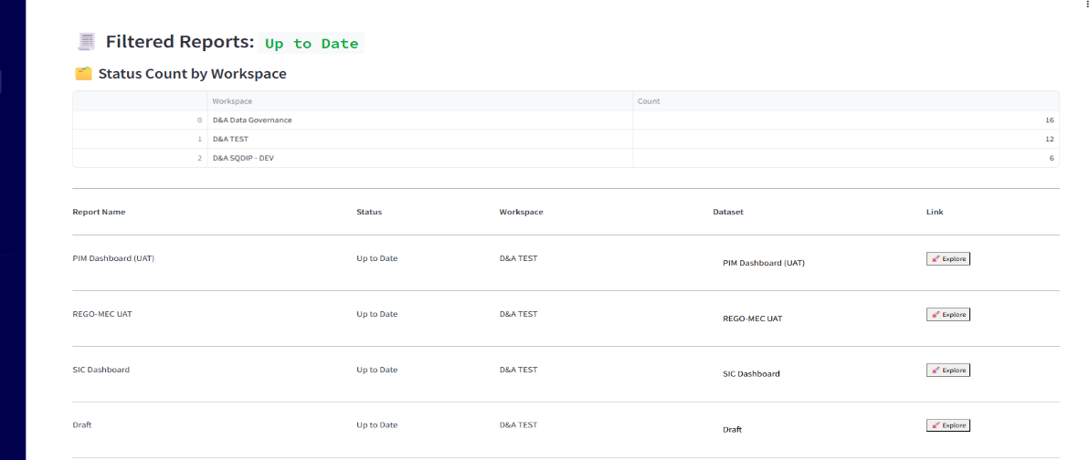



**Visualisations**

This section includes two key visualizations that help users understand the status distribution of Power BI reports across selected workspaces.

The below visualisations focuses on showing reports status based on related dataset.

* **Up to Date**: Reports linked to datasets and actively maintained.
* **Needs Attention**: Reports that are linked but potentially outdated or inactive.
* **Expired**: Reports considered obsolete or unused for a long time.
* **Unknown:** Reports not linked to any dataset, making status determination impossible.

**Bar Chart** – Report Status Based on Dataset  
 To display the number of reports in each status category, grouped by workspace and based on their associated datasets.

**Pie Chart** – Overall Report Status Share (in %)  
To provide a percentage-based distribution of all reports by their current status,

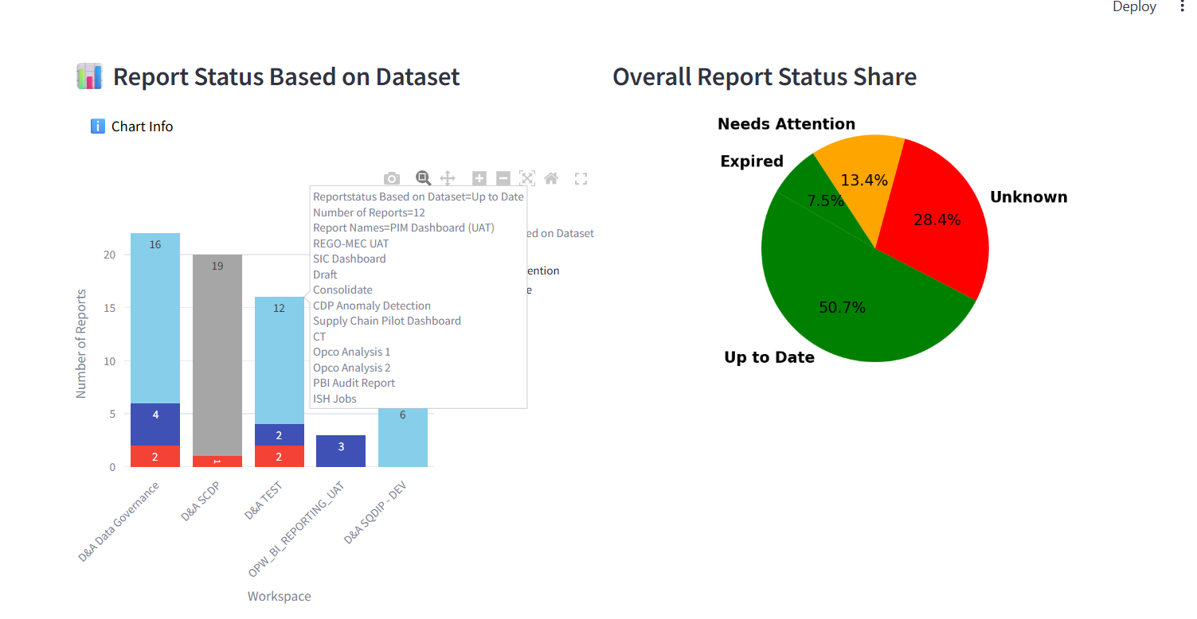

Click the View Reports and Explore Reports Dataframe buttons to explore reports for each workspace.

Clicking the link will redirect you to the corresponding report in the **Power BI Service workspace**, where you can view or manage it further.

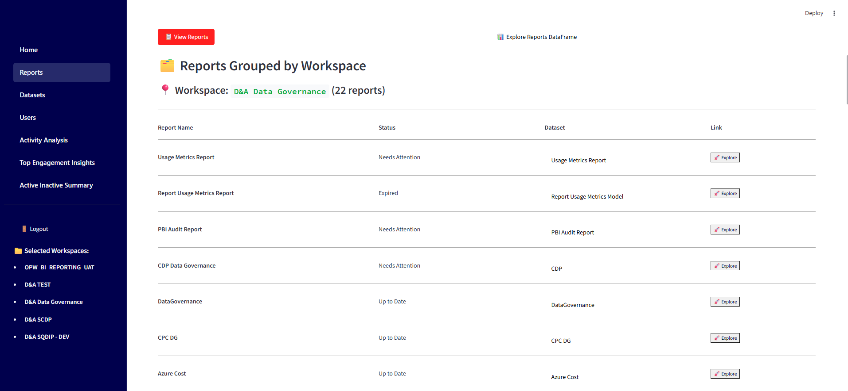

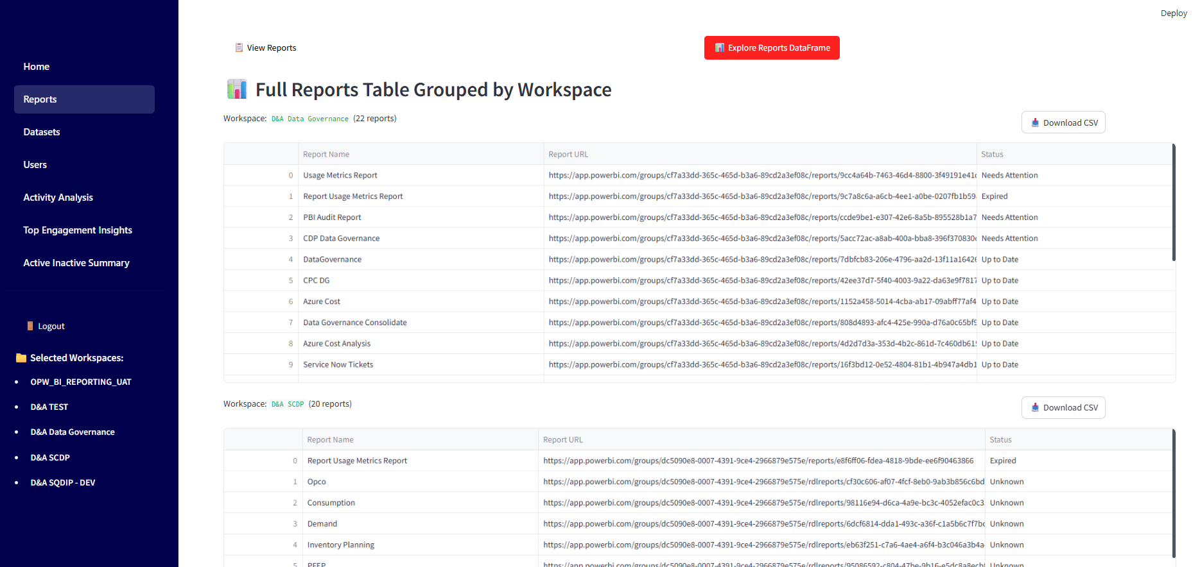



**DATASETS**

The **Datasets Page** provides an in-depth overview of all Power BI datasets available in the **selected workspaces**.

Users can track dataset health, monitor refresh status, analyze creation trends

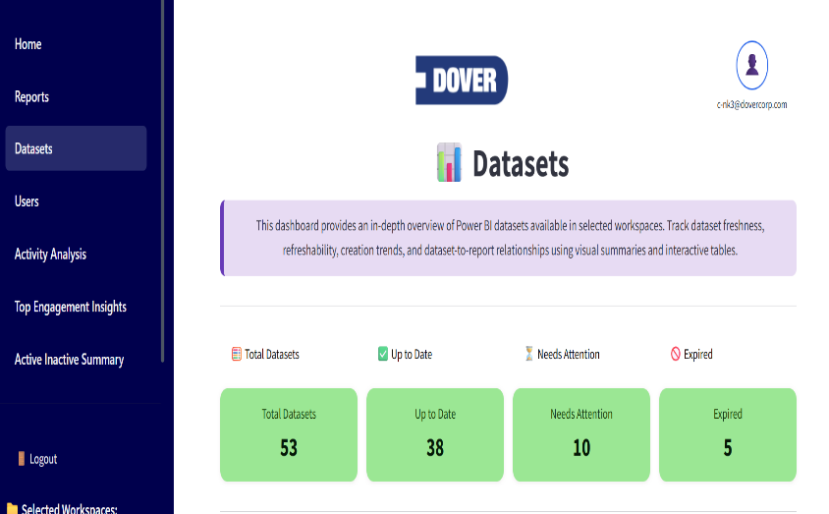Click any of the status buttons to filter and explore datasets based on their freshness:

Up to Date :  
 Displays datasets that have been created and refreshed within the last 12 months.

Needs Attention   
 Shows datasets where either the creation date older than 12 months, indicating potential staleness.

Expired   
 Lists datasets that have not been refreshed in over 12 months and are considered inactive or outdated.

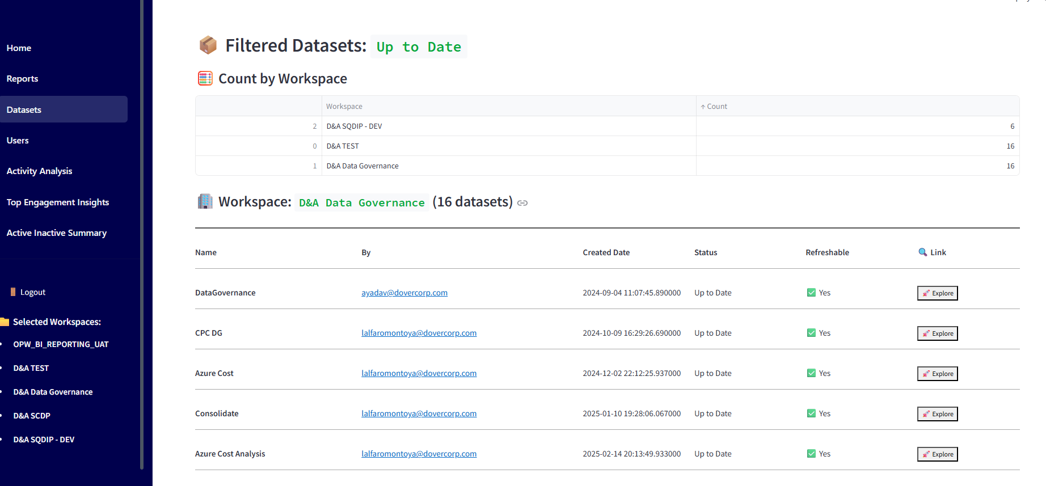

Visualisations :

**Refreshable vs Static Datasets (Bar Chart) -** This chart compares datasets based on their ability to refresh

**Dataset Creation Timeline (Line Chart) -** Displays the trend of dataset creation over time.

**Dataset Freshness Status by Workspace (Stacked Bar Chart) -** This visual breaks down the **freshness** of datasets per workspace

